Load state
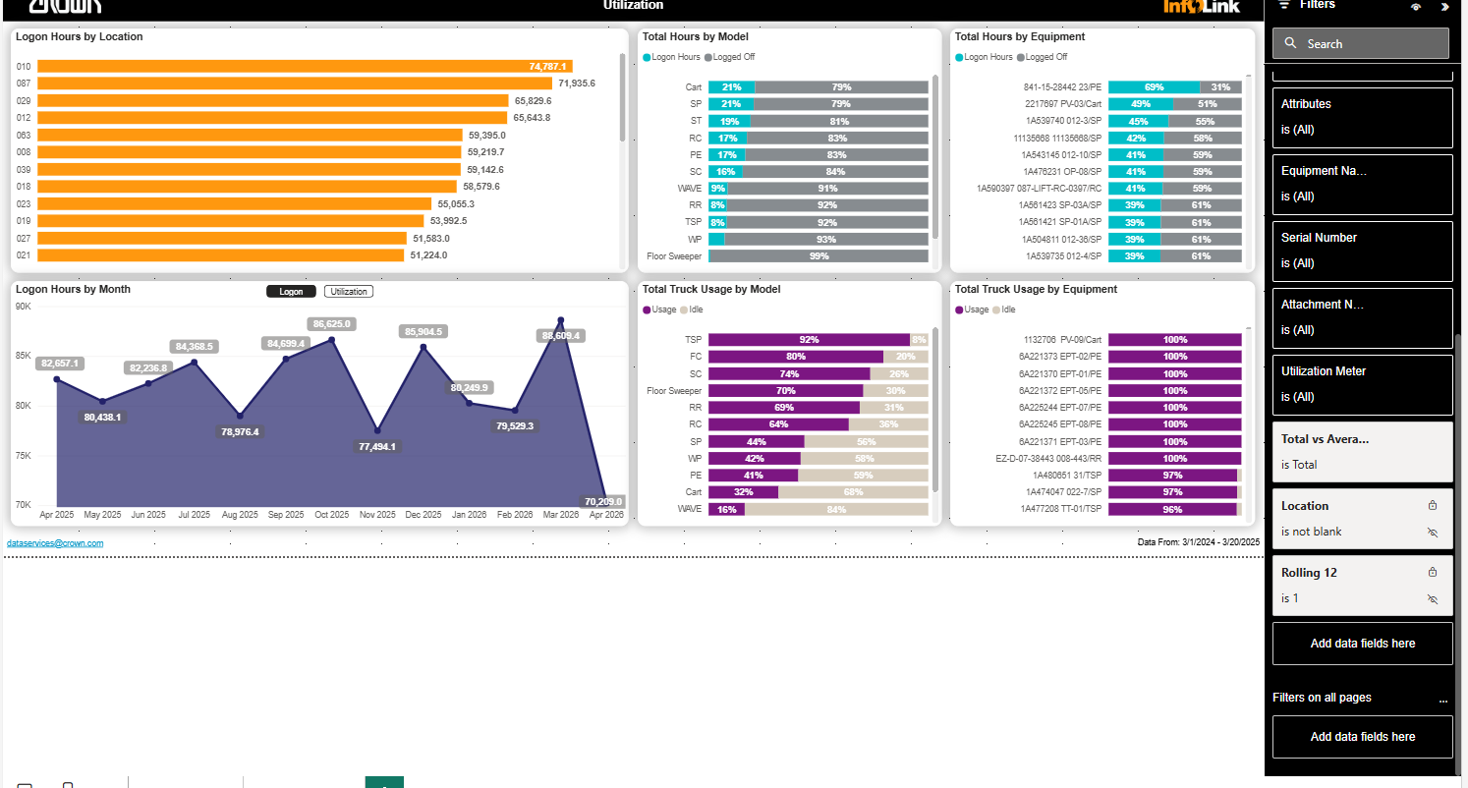

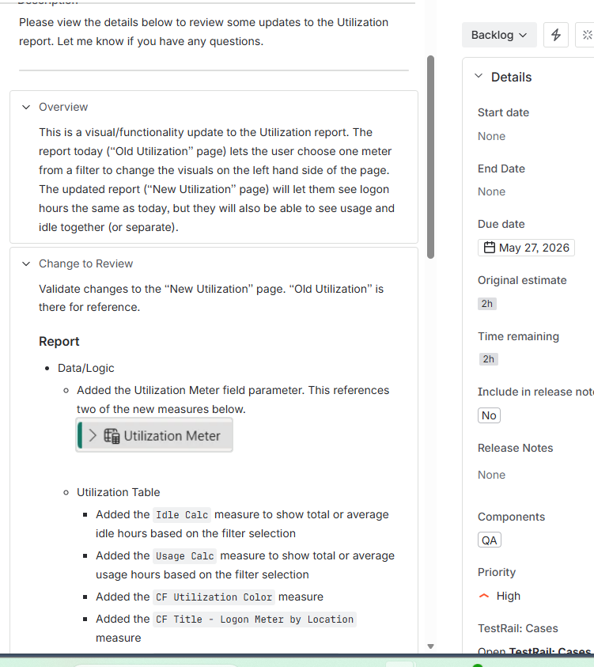
ticket
Validate changes to the “New Utilization” page. “Old Utilization” is there for reference.
Report
- Data/Logic
  - Added the Utilization Meter field parameter. This references two of the new measures below.

  - Utilization Table
    - Added the Idle Calc measure to show total or average idle hours based on the filter selection
    - Added the Usage Calc measure to show total or average usage hours based on the filter selection
    - Added the CF Utilization Color measure
    - Added the CF Title - Logon Meter by Location measure
    - Added the CF Title - Logon Meter by Month measure
    - Updated the “CF Title - Utilization…” measures to reference the new field parameter
- Visuals
  - Added the Utilization Meter column from the field parameter as a page filter
  - Duplicated the “by Location” and “by Month” charts to create a second version using the Utilization Meter column
  - Added CF Utilization Color to the new charts
  - Changed the original charts to use Total Logon only
  - Updated titles of charts appropriately
  - Created bookmarks to switch between the two views
Descriptionm

Utilization meter filter view

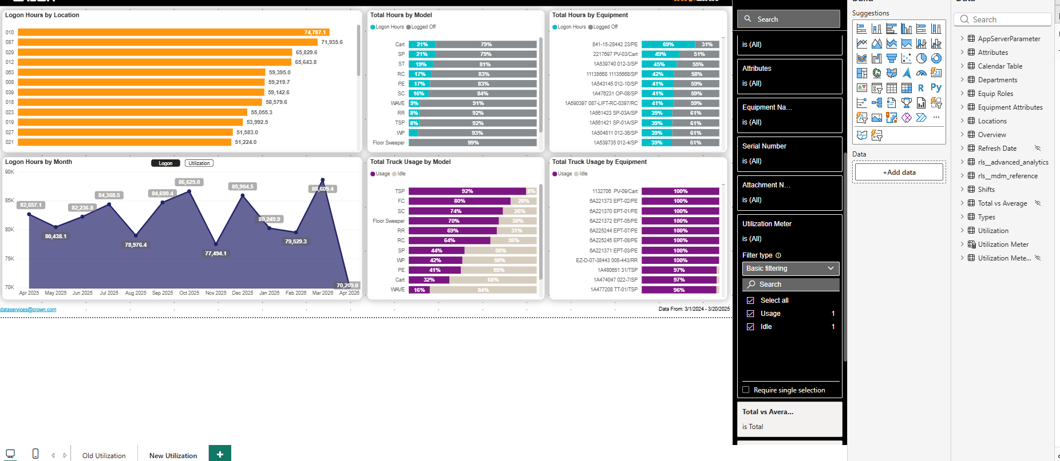

After making a selection
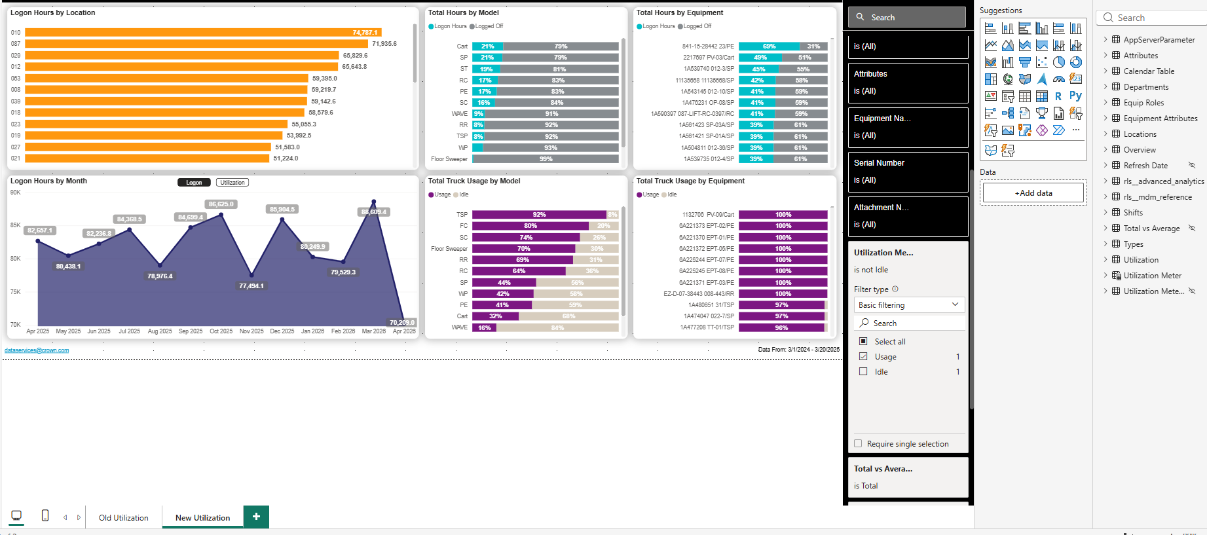

Both selection options off

